What is optimization ?

Optimization in phyton programs involves improving the performance,efficiency and speed of the code.Here are some techniques to optimize phyton programs.

Define types of optimization ?

1. Use built-in functions and libraries
2. Optimize loops
3. Use efficient data structures
4. Avoid global variables
5. Use caching
6. Profile and optimize hotpots
7. Use just in time compilation
8. Parallelize computations
9. Optimize memory usage

Minimize the function x^2+y^2+3x+4y+5 using phyton

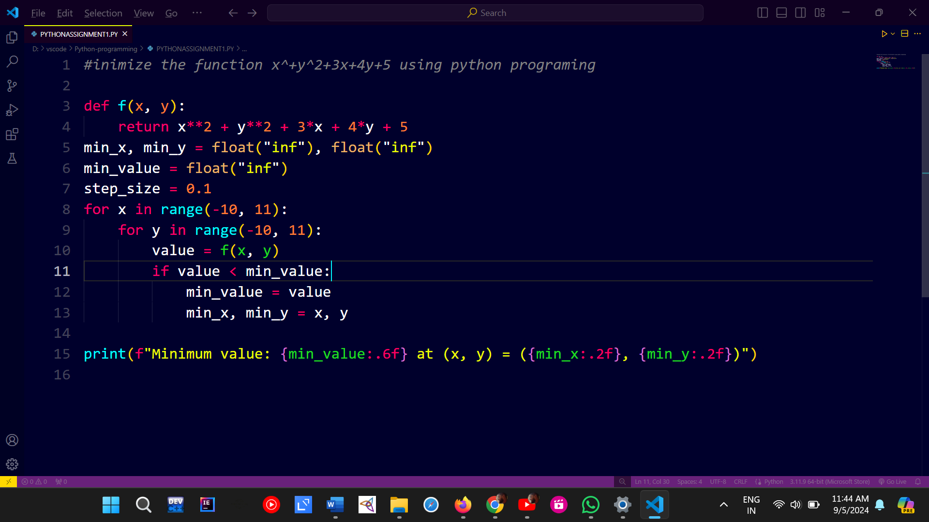

Output:

